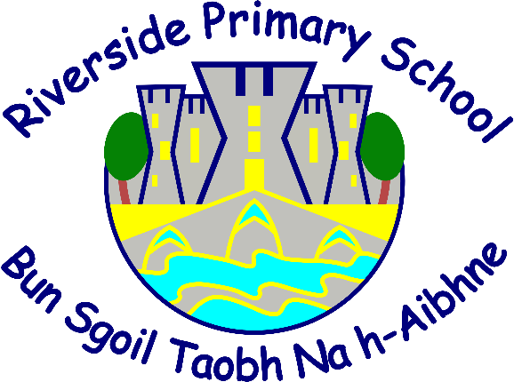

Clasaichean Gàidhlig/Gaelic Classes

Fiosrachadh airson Pàrantan/Information for parents
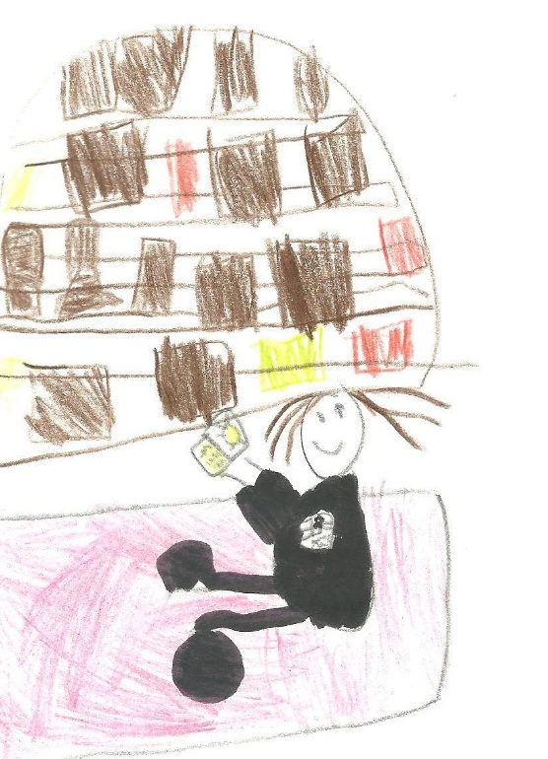

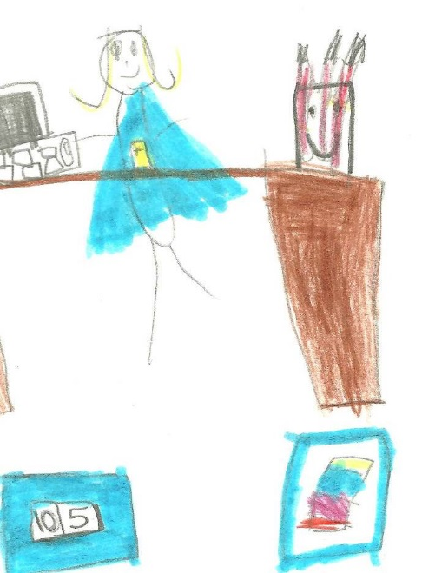

An t-Òg-mhios/June 2024

Buannachdan dà-chànanais/Benefits of bilingualism

Our main aim at Riverside is for children to be fluent and equally confident in both Gaelic and English by the time they leave primary school.

In doing so, they will also fulfil the aims and goals of Curriculum for Excellence whilst accruing all the benefits of bilingualism.

It is widely recognised that bilingualism confers educational and intellectual advantages
Between 60-65% of the world’s population use at least two languages in their everyday lives

Did you know?

It is easier to learn a third language if you are already bilingual
Having more than one language is much more common than having just one

Increased cultural and linguistic awareness

Aideachadh/Admission

Gaelic Medium Education at Riverside Primary caters for children from a variety of backgrounds - ranging from those who have encountered Gaelic in the home, through extended families or been exposed to it in the wider community. To others the school may provide the main context in which Gaelic is encountered. We fully support all children and respond positively in order to meet their individual needs.

Eagrachas/Organisation

At Riverside we follow A Curriculum for Excellence. This provides a broad and balanced curriculum, for all children throughout the whole school. There will be opportunities for your child to mix with other classes. These include playtimes, lunchtimes, house meetings, assemblies and other occasions throughout the school year. Your child may be taught in a multi-composite class and on rare occasions a year group may be split to accommodate class sizes.

Bogadh/Immersion Phase

At Riverside, the main emphasis in the first four years will be on gaining oral competence in speaking Gaelic. This is called the Total Immersion Phase which means Gaelic is the main language spoken the majority of the time. By the end of this phase pupils will be able to communicate with confidence in Gaelic with their peers and staff. It benefits your child to support the learning of Gaelic Literacy at home too.

We aim to:

- provide a total immersion experience by modelling high-quality Gaelic language in an engaging way
- provide a caring and nurturing environment in which to encourage all pupils to speak Gaelic as soon as possible
- praise and encourage the development of children’s social language and build confidence in its usage as their vocabulary extends
- ensure all children hear Gaelic in a range of contexts and have opportunities to hear Gaelic out with the classroom
- develop an awareness of the richness and diversity of Gaelic culture

To enable the children to achieve the above aims we implement a variety of teaching methods. These include many play based learning opportunities, including songs, structured play, language games, drama, storytelling, art activities, visual aids, modelling of words and phrases and many more. A great emphasis is made on praising all attempts made by the children.

Taic le Ionnsachadh Dachaigh/Support with Home Learning

Instructions for Gaelic homework will be written in English, and in some cases, some Gaelic words used as part of the home learning may be written phonetically to help with pronunciation. There are also many online websites supporting Gaelic at home. Reading books used in the Total Immersion Phase can be accessed online and listened to at home. All necessary information will be shared with homework.

Clas 4-7/Primary 4-7

Coming towards the end of the total immersion phase, children are confident in spoken Gaelic. English is now introduced as a second language in Reading and Writing. Children will continue Reading and Writing in Gaelic but are introduced to English language teaching during their Literacy lessons in P4. Our experience is that skills that are taught in Gaelic language transfer readily into English.

The amount of time spent on English language increases gradually over the years. By the end of Primary 7 most children will be equally proficient in both English and Gaelic.

It should be noted that all other subjects in the curriculum are taught through the medium of Gaelic.

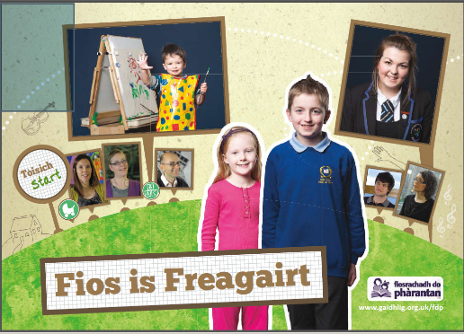
Ceistean/Frequently Asked Questions

Alongside this P1 information booklet, you will
also receive a ‘Fios is Freagairt' (Information
and Answer) pack. This is also available online
- http://www.parant.org.uk/pdfs/fisf.pdf.

This answers many questions that parents who
chose Gaelic Medium Education for their children
have previously asked.

Also included are some helpful websites, such as www.Gaelic4Parents.com which provides online Gaelic language and homework support for parents.
If you have any further questions, please get in touch with us at the school.

We look forward to teaching your child and working in partnership with you.

