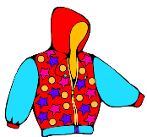[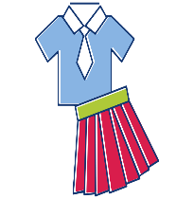](https://www.google.co.uk/url?sa=i&url=https://www.clipart.email/clipart/school-uniform-clipart-png-100246.html&psig=AOvVaw3-LFFNcHcka-0rPT-PVIVd&ust=1587390513726000&source=images&cd=vfe&ved=0CAIQjRxqFwoTCMDay8_Q9OgCFQAAAAAdAAAAABAE)[](https://www.google.co.uk/url?sa=i&url=http://clipart-library.com/free-sun-cliparts.html&psig=AOvVaw3MuxgbwMRSQBh0qC3vH9bE&ust=1587391459109000&source=images&cd=vfe&ved=0CAIQjRxqFwoTCMD8rJLU9OgCFQAAAAAdAAAAABAE)[](https://www.google.co.uk/url?sa=i&url=https://www.pinterest.com/pin/495747871476905455/&psig=AOvVaw319N7cci66-mab247wKdQt&ust=1587391765519000&source=images&cd=vfe&ved=0CAIQjRxqFwoTCPCsrKTV9OgCFQAAAAAdAAAAABAO)[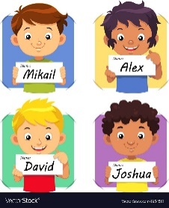](https://www.google.co.uk/url?sa=i&url=https://www.pinterest.com/pin/242631498664940891/&psig=AOvVaw1ZqJyl-4yzemetTCx1kRRo&ust=1587390862551000&source=images&cd=vfe&ved=0CAIQjRxqFwoTCJjA6PXR9OgCFQAAAAAdAAAAABAJ)[](https://www.google.co.uk/url?sa=i&url=http://clipart-library.com/knife-and-fork.html&psig=AOvVaw071Cetx835cXys1h2uniEJ&ust=1587390324460000&source=images&cd=vfe&ved=0CAIQjRxqFwoTCMDliPXP9OgCFQAAAAAdAAAAABAE)[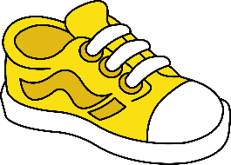](https://www.google.co.uk/url?sa=i&url=https://webstockreview.net/explore/clipart-shoes-kid-shoe/&psig=AOvVaw3hrc589A55uOvnFi-54GVT&ust=1587390413375000&source=images&cd=vfe&ved=0CAIQjRxqFwoTCKC9h6DQ9OgCFQAAAAAdAAAAABAJ)[](https://www.google.co.uk/url?sa=i&url=https://clipartart.com/categories/clipart-of-books-free.html&psig=AOvVaw38lD_Y_t9YwIbPNbmLLtEJ&ust=1587390151398000&source=images&cd=vfe&ved=0CAIQjRxqFwoTCKiy7qLP9OgCFQAAAAAdAAAAABAE)A picture containing drawing

P.E. will require children to change independently in and out of gym kits/school uniform. Give this a go. Can they zip up their coat too?

Finally, PLAY, PLAY, PLAY and enjoy the sunshine! Have some quality family time.

The following are possibilities **only** if your child is ready and interested. Can your child read/ recognise and write their name? Practise writing it properly with a capital letter only at the beginning of it. Can they hold their pencil properly? Show them the correct way to grip the pencil and let them try this.

Practise holding and using scissors properly and safely.

Teach them how to use cutlery, hold plates and trays independently.

Can your child access the toilet independently and sensibly? Can they wash their hands well? If not, this is something to work on.

Can your child play independently? Can they play well with others and take turns? Practise this.



**Getting your child ready for Primary 1**

Parent/Carer Pointers:

* We know that beginning the P1 learning journey can be a daunting time for children and parents alike. Please try as much as possible not to share your worries with your children and try to portray this as an exciting and positive experience. Children will follow your lead.
* LABEL EVERYTHING – Things can become lost and mixed up easily in the classroom and young children often can’t recognise their belongings (items of clothing, bags, lunchboxes, water bottles etc). A name on all belongings is very helpful.
* Children will not need a pencil case. Although a water bottle is handy – it can become hot in the classroom and learning is a thirsty business. The bottle will be sent home daily to be refilled and washed.
* Clothing - Velcro shoes are the best for encouraging children to get themselves ready independently. When you know your child’s P.E. days it is also helpful to allow children to wear uniform without shirts or ties as these can be tricky for little fingers!
* You will be given a lunch menu at various points throughout the year – including at the start of P1. Keep this safe. You can use it to discuss the lunches available that day with your child if you think they will find it difficult to choose. This is also available on the school website.
* P1 teachers know that your children are precious little people and will treat them as such. We want this to be an enjoyable experience for all! Please trust that we will do all we can for them every day and relax – they are in good hands!



**Getting your child ready for Primary 1**

Skills/Activities that are handy for starting the learning journey

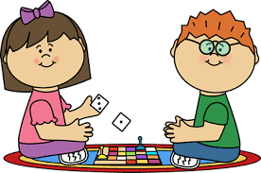

Teach them how to tie their laces or how to use Velcro shoes. Do they know which shoe is for which foot?

Read to your child often. Explain the meaning of new words. Point out rhyming words.